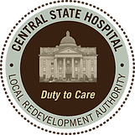
Central State Hospital Local Redevelopment Authority

BOARD MEETING

The regular monthly board meeting for the Central State Hospital Local Redevelopment Authority will be held on Wednesday, February 18, 2026, at 5:00 PM in the CSHLRA office located at 220 Thomas Field Rd., Milledgeville, GA 31061.

Regards,

Calvin McMullen
Calvin McMullen
CSHLRA Chairman

