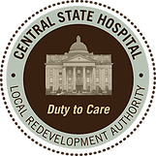
Central State Hospital Local Redevelopment Authority

Executive Committee Meeting

The regular monthly executive committee meeting for the Central State Hospital Local Redevelopment Authority will be held on Thursday, February 12, 2026, at 12:00 PM in the CSHLRA office located at 220 Thomas Field Rd., Milledgeville, GA 31061.

Regards,
Calvin McMullen
Calvin McMullen
CSHLRA Chairman

