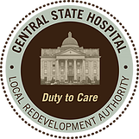
Central State Hospital Local Redevelopment Authority

GIFC, LLC MEETING
A GIFC, LLC Board meeting will be held on Wednesday, July 15, 2026, at 5:30 PM in the CSHLRA office located at 220 Thomas Field Rd., Milledgeville, GA 31061.

Regards,
Robert Binion
Robert Binion
CSHLRA Chairman

